Kubernetes Task 1

Set up MiniKube on your local machine.

Setup k8s master and two worker nodes on Ubuntu.

Run one Nginx pod.

Mugup Master and slave components on k8s.

Step 1 — Install Minikube
Open the official Minikube installation page:
For Windows, install the AMD64 version.
Once Minikube is installed, come back to VS Code PowerShell and run:
minikube version

Step 2 — Add Minikube to your user PATH
Run:
$userPath = [Environment]::GetEnvironmentVariable("Path", "User")

if ($userPath -notlike "*C:\minikube*") {
[Environment]::SetEnvironmentVariable("Path", "$userPath;C:\minikube", "User")
}
Step 3 — Close VS Code completely
This is important because the current VS Code terminal won't automatically receive the new PATH.
Close all VS Code windows, reopen VS Code, open a new PowerShell terminal, and run:
minikube version
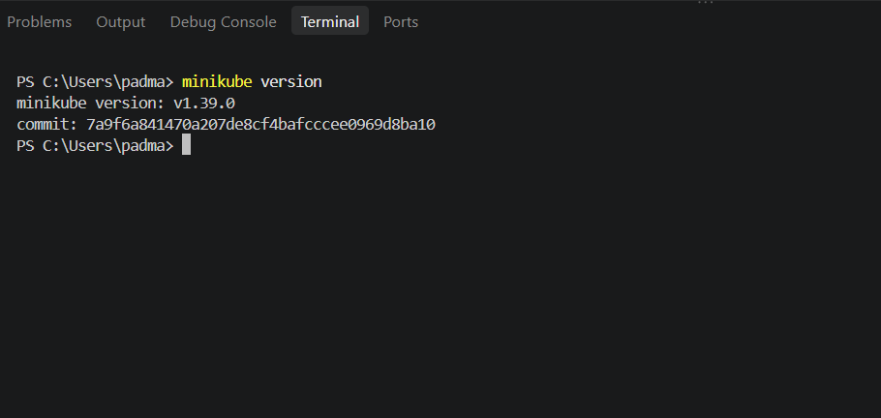
Next: Start Minikube
Because Docker is working, we'll explicitly tell Minikube to use Docker:
minikube start --driver=docker
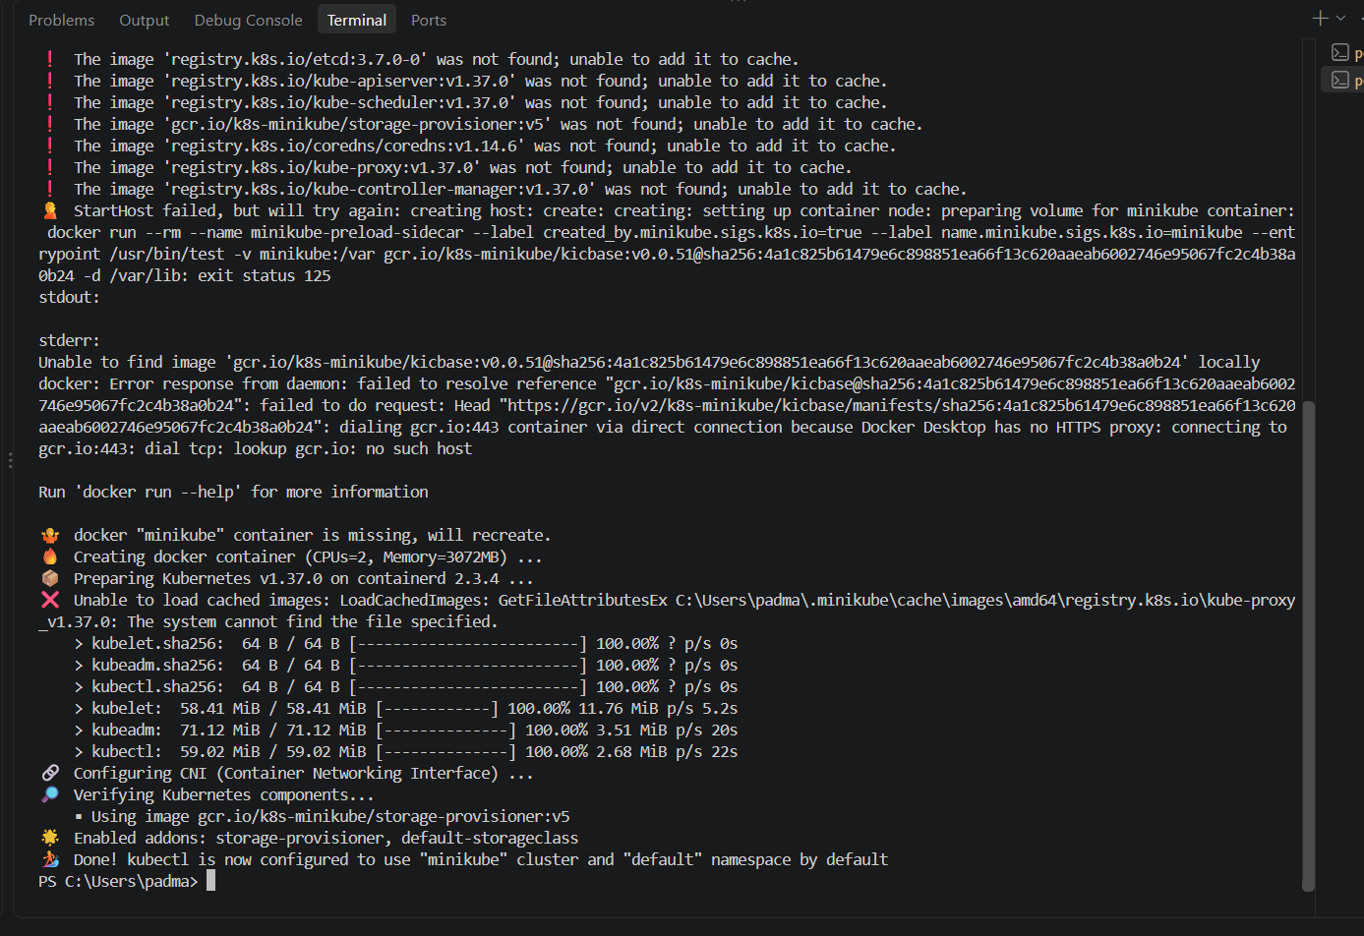
Step 1 — Verify the Minikube node
Run:
kubectl get nodes
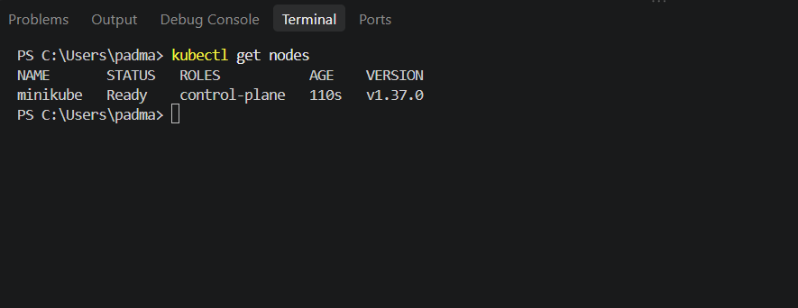
Then run:
minikube status
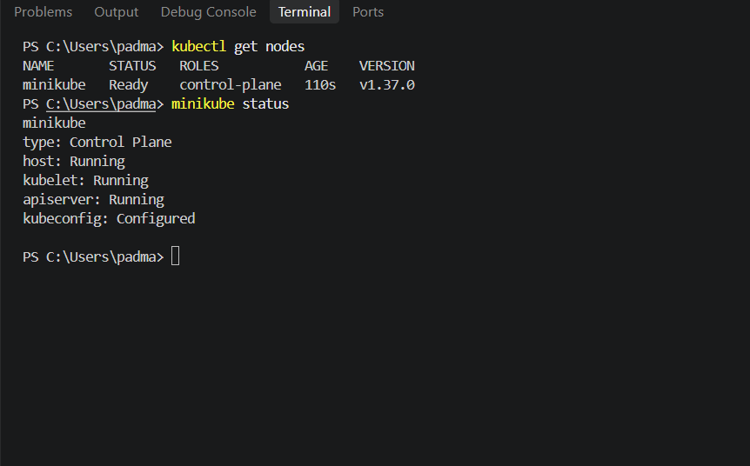
Next — Create the nginx Pod
Now let's do the actual Kubernetes task.
Run:
kubectl run nginx --image=nginx
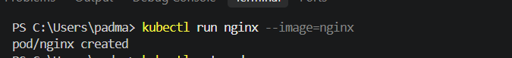
Then check:
kubectl get pods
We should eventually see:
NAME READY STATUS RESTARTS AGE
nginx 1/1 Running 0 ...
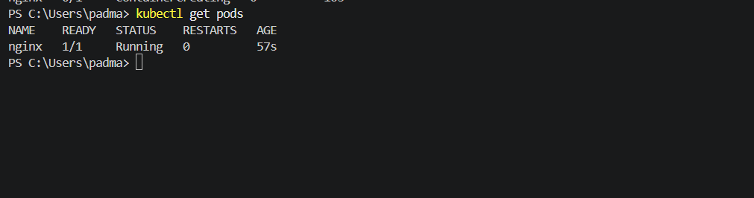
What just happened?
You ran:
kubectl run nginx --image=nginx
Kubernetes did this:
kubectl
│
▼
Kubernetes API Server
│
▼
Pod: nginx
│
▼
Container: nginx
│
▼
Node: minikube
Let's verify the Pod's node
Run:
kubectl get pods -o wide
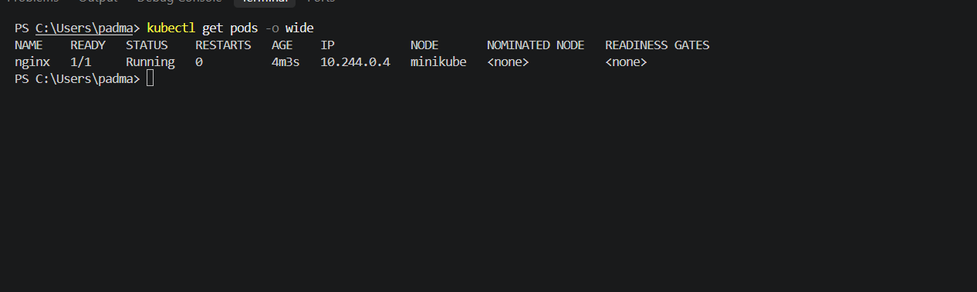
This confirms the nginx Pod is running on your Minikube node.
NAME READY STATUS RESTARTS AGE IP NODE
nginx 1/1 Running 0 4m 10.244.0.4 minikube

4.Master + 2 Worker node cluster on Ubuntu,
Create 3 ubuntu instances in AWS
Step 1 — Launch the first EC2 instance
Go to AWS Console → EC2 → Instances → Launch instance.
Use these settings:
Name
k8s-master
AMI
Ubuntu Server 24.04 LTS
64-bit (x86)
Instance type
t3.medium
Key pair
Use your existing SSH key pair.
Network
- Use the same VPC/subnet you'll use for all three instances.
- Auto-assign Public IP: Enable.
Security Group
Create a new security group named:
k8s-lab-sg
For the initial setup, add:
Type | Port | Source
SSH | 22 | My IP
Custom TCP | 6443 | Your IP
All traffic | — | Custom → the same security group
The same security group will be attached to all three Kubernetes instances, allowing node-to-node communication.
For a temporary learning lab, this is much simpler than manually adding every Kubernetes port. We can tighten the rules later if required.
Storage: 20 GiB gp3.
Then click Launch instance.
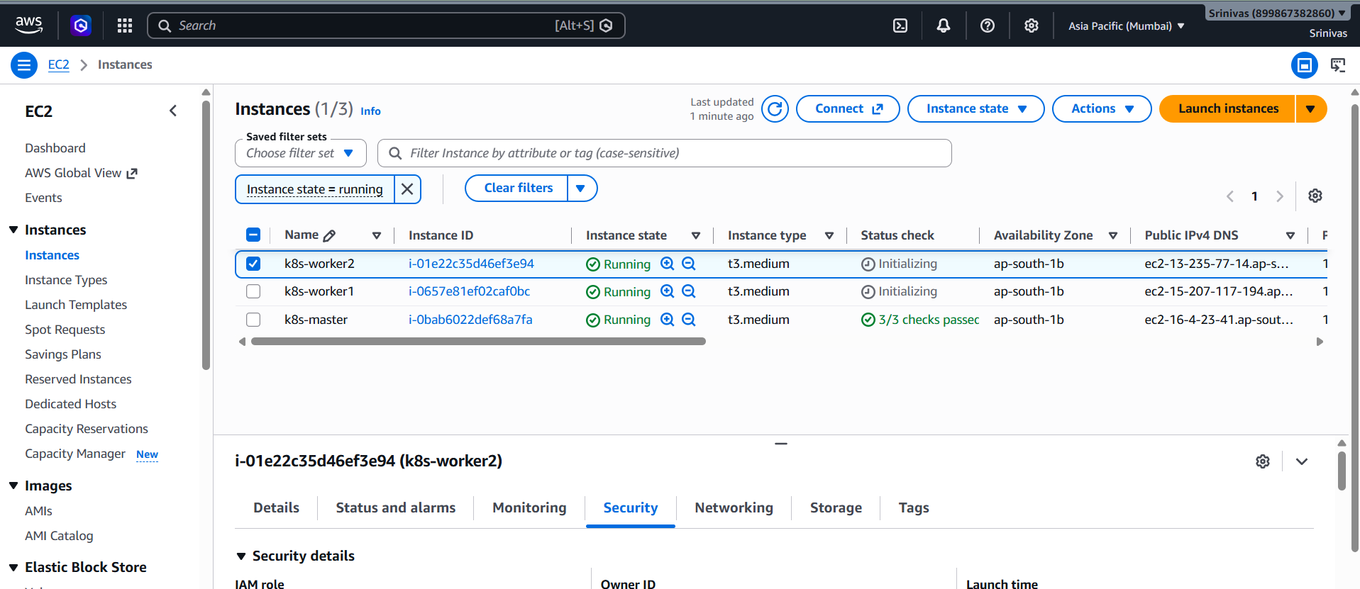
Create Another 2 Instances For worker machines with same security groups
Then use:
ssh -i "YOUR-KEY.pem" ubuntu@MASTER_PUBLIC_IP
Connect to ssh
Step 1 — Update the Ubuntu packages
On the Master, run:
sudo apt update && sudo apt upgrade -y
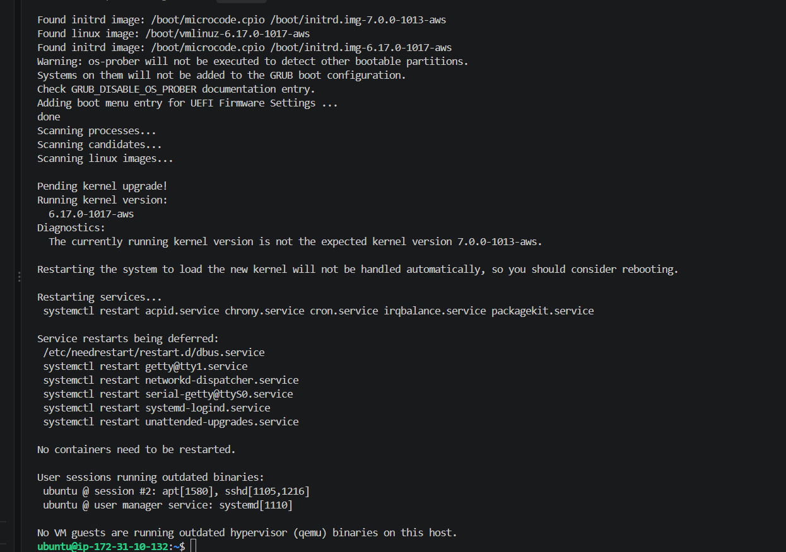
Step 2 — Reboot the Master
Run:
sudo reboot
Your SSH connection will disconnect. That's normal.
Step 3 — Reconnect to the Master
Use the same SSH command you used before:
Once connected, run:
uname -r
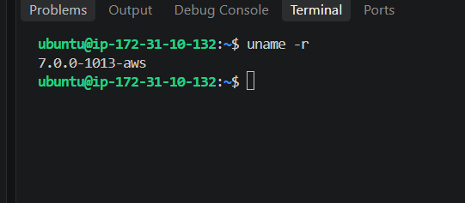
Step 4 — Install containerd
For this Kubernetes cluster, we'll use containerd as the container runtime.
Run on the Master:
sudo apt install -y containerd
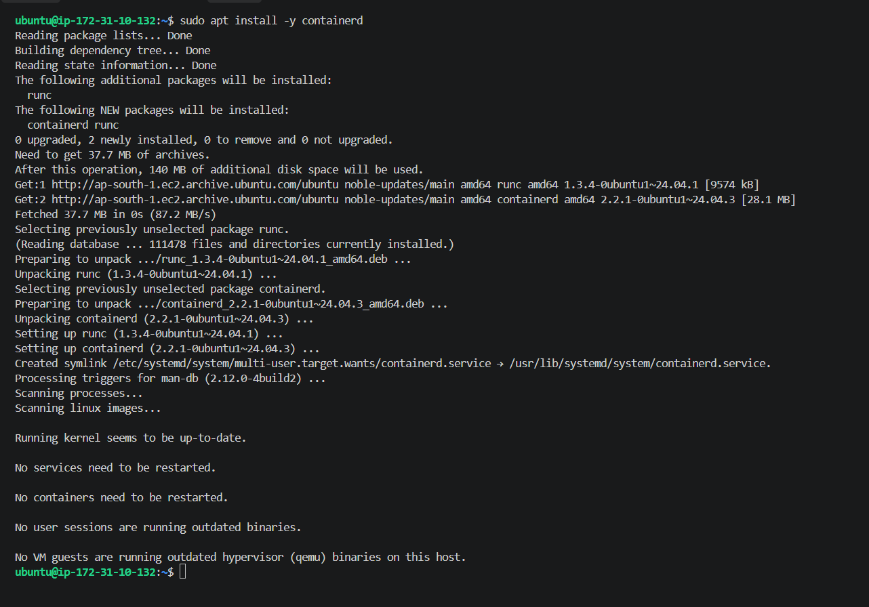
Run This Commands As Well
sudo mkdir -p /etc/containerd
containerd config default | sudo tee /etc/containerd/config.toml
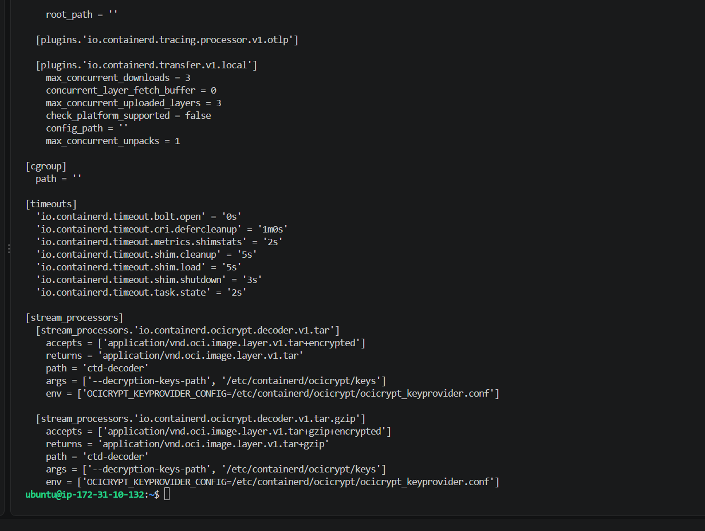
The containerd configuration file was created successfully.
Step 5 — Configure containerd for Kubernetes
Kubernetes should use the systemd cgroup driver with containerd.
Run this command:
sudo sed -i 's/SystemdCgroup = false/SystemdCgroup = true/' /etc/containerd/config.toml
Then restart containerd:
sudo systemctl restart containerd
Check that it is running:
sudo systemctl status containerd --no-pager
We want to see:
Active: active (running)
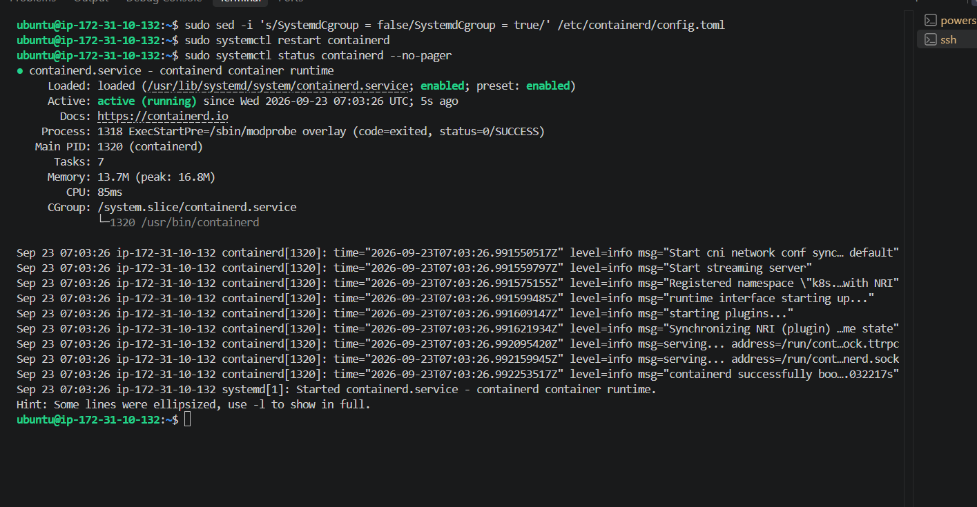
So the Master is progressing correctly.
Step 6 — Disable swap
Kubernetes requires swap to be disabled for this setup.
Run:
sudo swapoff -a
Then make it permanent after reboot:
sudo sed -i '/\sswap\s/s/^/#/' /etc/fstab
Verify:
free -h
Look at the Swap row. We want:
Swap: 0B 0B 0B
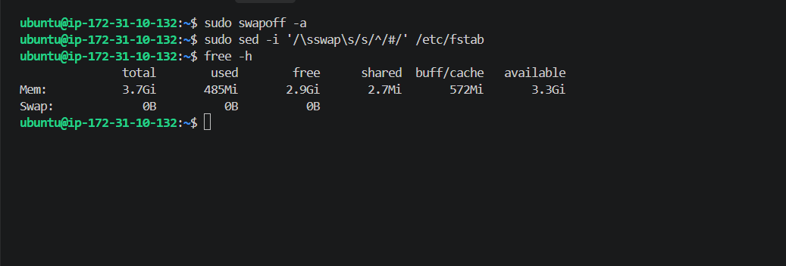
Step 7 — Enable required kernel modules
Run these commands on the Master:
sudo modprobe overlay
sudo modprobe br_netfilter
Then make them load automatically after reboot:
cat <<EOF | sudo tee /etc/modules-load.d/k8s.conf
overlay
br_netfilter
EOF
Then configure Kubernetes networking:
cat <<EOF | sudo tee /etc/sysctl.d/k8s.conf
net.bridge.bridge-nf-call-iptables = 1
net.bridge.bridge-nf-call-ip6tables = 1
net.ipv4.ip_forward = 1
EOF
Apply the settings:
sudo sysctl --system
Finally verify:
sysctl net.ipv4.ip_forward
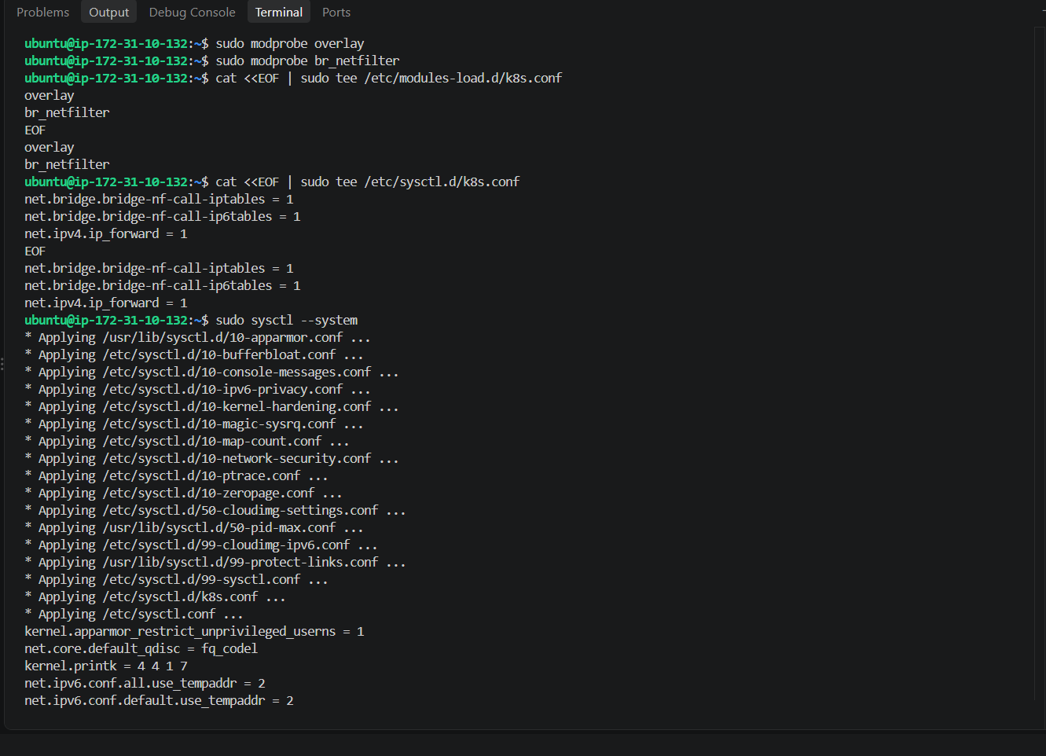
Next task — Install Kubernetes packages
Now we need to install:
kubeadm → creates/initializes the cluster
kubelet → runs Kubernetes workloads on the node
kubectl → command-line tool to manage Kubernetes
We'll install the same versions on Master and both Workers.
For now, only on the Master, run:
sudo apt-get update
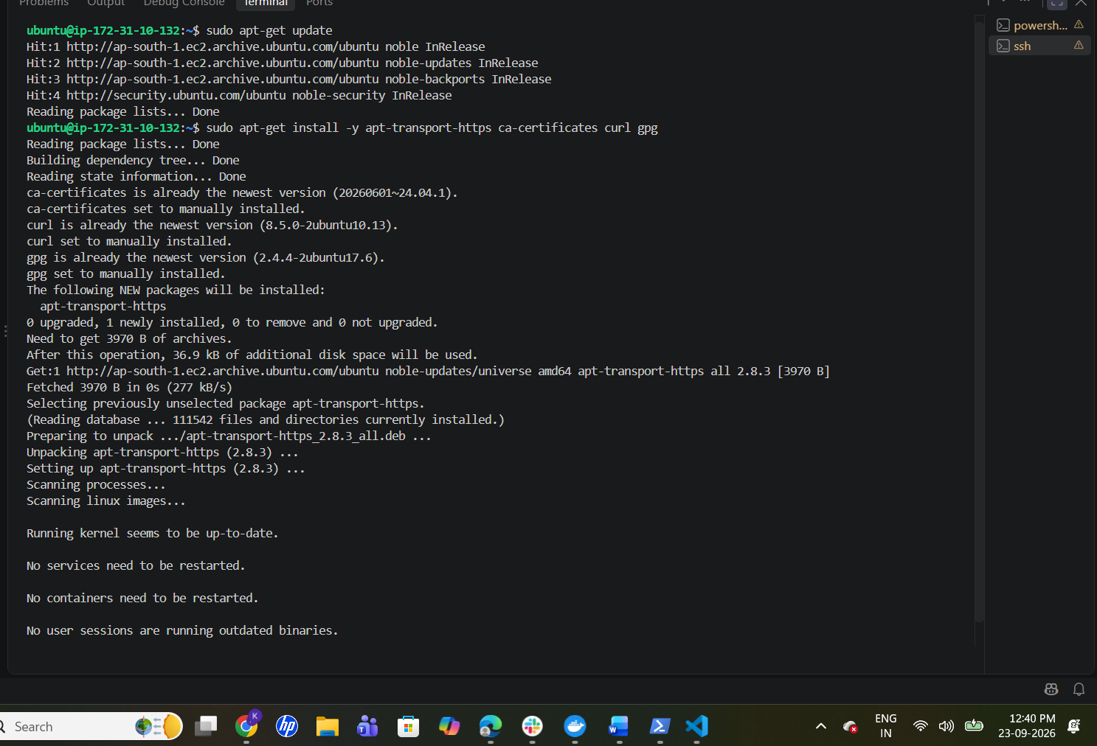
Step 8 — Add Kubernetes repository
Run these commands on the Master:
sudo mkdir -p -m 755 /etc/apt/keyrings
Then:
curl -fsSL https://pkgs.k8s.io/core:/stable:/v1.34/deb/Release.key | sudo gpg --dearmor -o /etc/apt/keyrings/kubernetes-apt-keyring.gpg
Then:
echo 'deb [signed-by=/etc/apt/keyrings/kubernetes-apt-keyring.gpg] https://pkgs.k8s.io/core:/stable:/v1.34/deb/ /' | sudo tee /etc/apt/sources.list.d/kubernetes.list
Then update: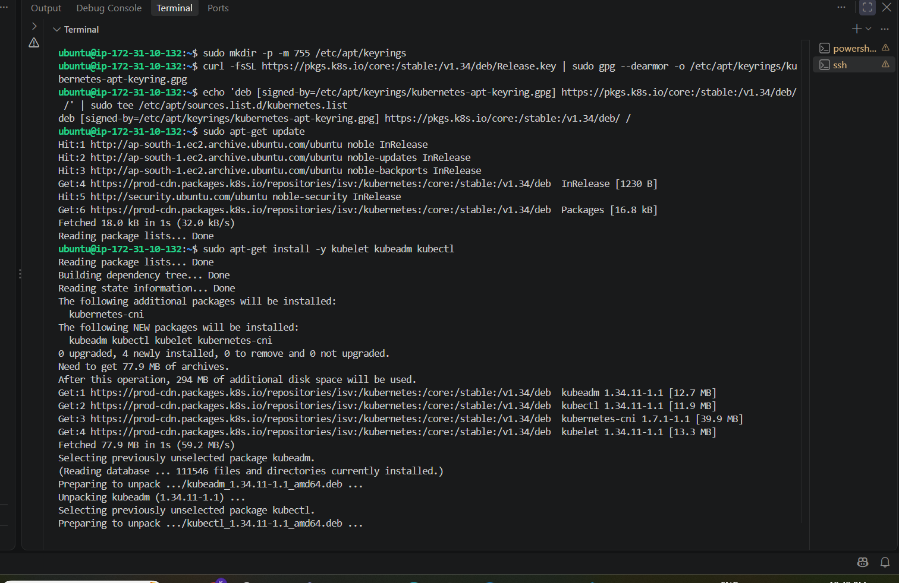
sudo apt-get update
Then install Kubernetes
sudo apt-get install -y kubelet kubeadm kubectl
And prevent automatic version changes:
sudo apt-mark hold kubelet kubeadm kubectl
Verify
Run:
kubeadm version
kubectl version --client
kubelet –version
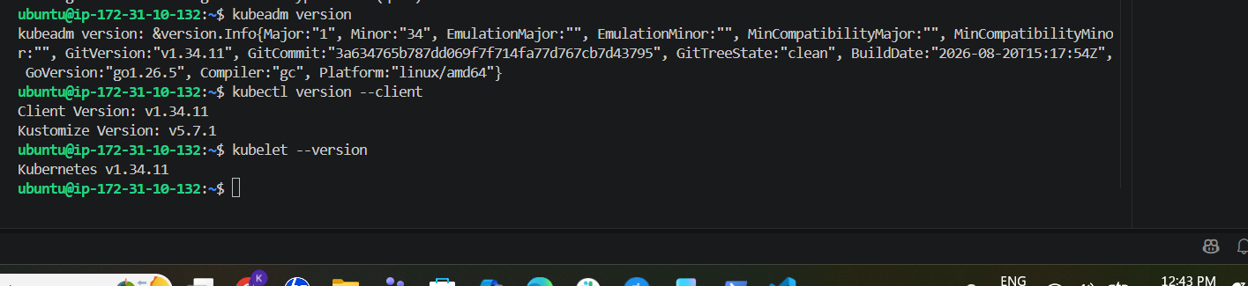
Next task: prepare kubelet
Run:
sudo systemctl enable --now kubelet
Then check:
sudo systemctl status kubelet --no-pager
Don't worry if kubelet shows activating or errors about configuration right now. We haven't initialized the Kubernetes control plane yet, so kubelet may not be fully functional yet. kubeadm init will provide its configuration.
Next — Initialize the Kubernetes Control Plane
Before running kubeadm init, we need to know the private IP of this Master.
Run:
hostname -I
Step — Initialize Master
Run this on the Master only:
sudo kubeadm init --apiserver-advertise-address=172.31.10.132 --pod-network-cidr=10.244.0.0/16
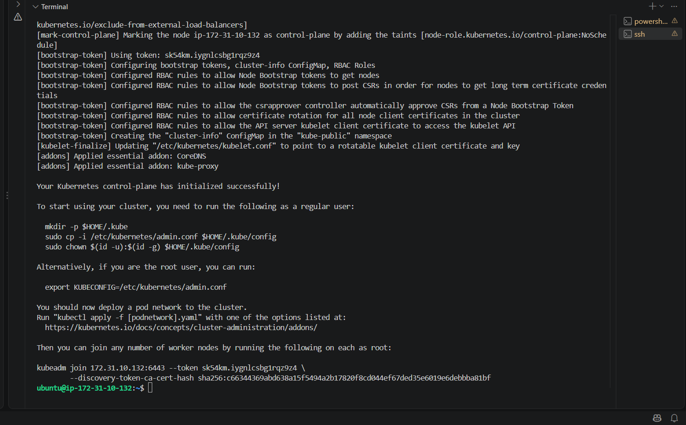
Next — Configure kubectl on the Master
Run these three commands on the Master:
mkdir -p $HOME/.kube
sudo cp -i /etc/kubernetes/admin.conf $HOME/.kube/config
sudo chown $(id -u):$(id -g) $HOME/.kube/config
Then verify:
kubectl get nodes
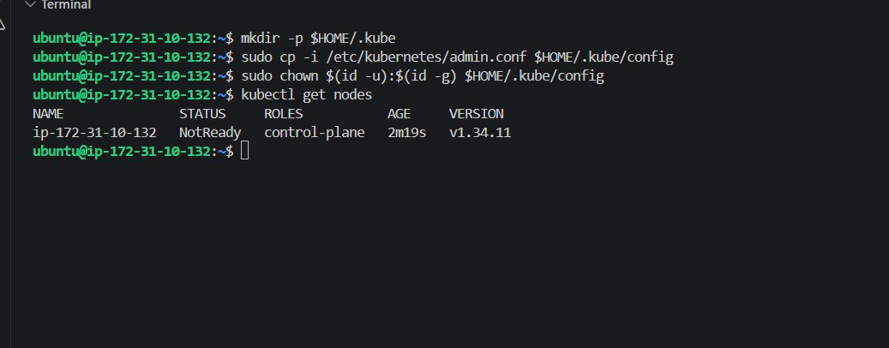
Control Plane is initialized, but it is currently:
ip-172-31-10-132 NotReady control-plane
The reason is that we haven't installed the Pod network yet.
Next task — Install Flannel Pod Network
Since we initialized the cluster with:
--pod-network-cidr=10.244.0.0/16
we can use Flannel, which uses that same Pod CIDR.
On the Master, run:
kubectl apply -f https://github.com/flannel-io/flannel/releases/latest/download/kube-flannel.yml
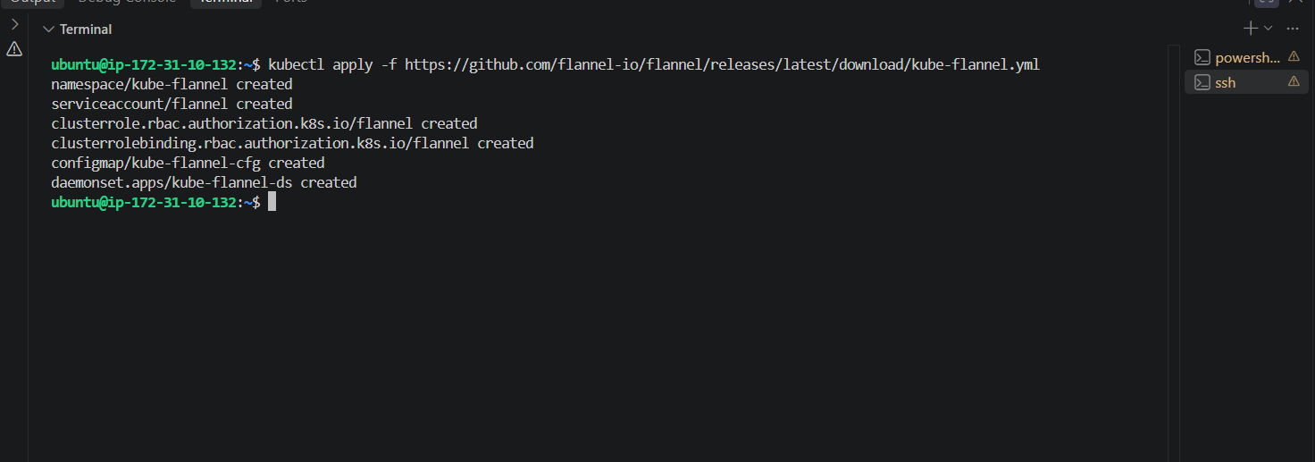
Then wait around 30–60 seconds and run:
kubectl get nodes
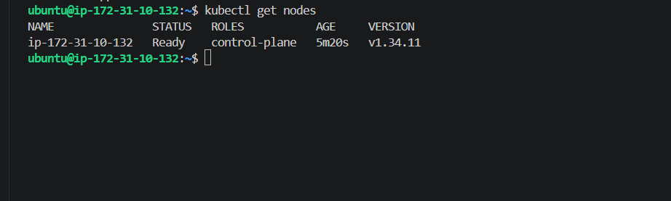
We need to do same process for the worker 1 and worker 2 instances
Next: Setup Worker 2
SSH into your Worker 2 EC2 instance:
1. Update & reboot
sudo apt update && sudo apt upgrade -y
If it says a new kernel is installed, run:
sudo reboot
Reconnect after reboot and verify:
uname -r
2. Install containerd
sudo apt install -y containerd && \
sudo mkdir -p /etc/containerd && \
containerd config default | sudo tee /etc/containerd/config.toml > /dev/null && \
sudo sed -i 's/SystemdCgroup = false/SystemdCgroup = true/' /etc/containerd/config.toml && \
sudo systemctl restart containerd && \
sudo systemctl enable containerd && \
sudo systemctl status containerd --no-pager
3. Disable swap
sudo swapoff -a && \
sudo sed -i '/\sswap\s/s/^/#/' /etc/fstab && \
free -h
4. Kubernetes networking
sudo modprobe overlay && \
sudo modprobe br_netfilter && \
cat <<EOF | sudo tee /etc/modules-load.d/k8s.conf
overlay
br_netfilter
EOF

cat <<EOF | sudo tee /etc/sysctl.d/k8s.conf
net.bridge.bridge-nf-call-iptables = 1
net.bridge.bridge-nf-call-ip6tables = 1
net.ipv4.ip_forward = 1
EOF

sudo sysctl --system && \
sysctl net.ipv4.ip_forward
Expected:
net.ipv4.ip_forward = 1
5. Install Kubernetes
sudo apt-get update && \
sudo apt-get install -y apt-transport-https ca-certificates curl gpg && \
sudo mkdir -p -m 755 /etc/apt/keyrings && \
curl -fsSL https://pkgs.k8s.io/core:/stable:/v1.34/deb/Release.key | sudo gpg --dearmor -o /etc/apt/keyrings/kubernetes-apt-keyring.gpg && \
echo 'deb [signed-by=/etc/apt/keyrings/kubernetes-apt-keyring.gpg] https://pkgs.k8s.io/core:/stable:/v1.34/deb/ /' | sudo tee /etc/apt/sources.list.d/kubernetes.list && \
sudo apt-get update && \
sudo apt-get install -y kubelet kubeadm kubectl && \
sudo apt-mark hold kubelet kubeadm kubectl && \
sudo systemctl enable --now kubelet
6. Join Worker 2
After all the above succeeds:
sudo kubeadm join 172.31.10.132:6443 --token sk54km.iygnlcsbg1rqz9z4 \
--discovery-token-ca-cert-hash sha256:c66344369abd638a15f5494a2b17820f8cd044ef67ded35e6019e6debbba81bf
Then go to Master:
kubectl get nodes
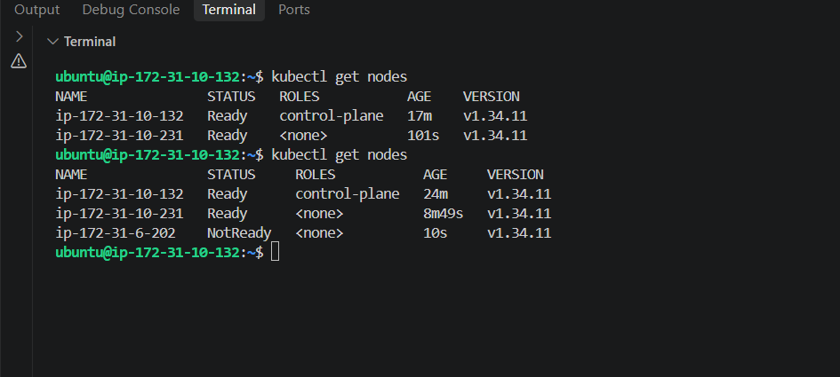
Repeat the same process for worker 2 as well

Final task: Deploy NGINX
Run this on Master:
kubectl run nginx --image=nginx
Then check:
kubectl get pods -o wide
